 | 

DEPARTMENT OF ARTIFICIAL INTELLIGENCE AND DATA SCIENCE

MINI PROJECT REPORT

SUPERMARKET AND GROCERY SALES ANALYSIS
Exploratory Data Analysis, Visualization and Data Preprocessing

Submitted by
RISHVANTH S (814725243138)
SABARISH M (814725243146)
II AI & DS - C

Under the Guidance of
V. EZHIL SWANLY

Submission Date: 24 October 2026

CERTIFICATE
This is to certify that the mini project report titled “Supermarket and Grocery Sales Analysis” is submitted by RISHVANTH S, with team member SABARISH M, from the Department of Artificial Intelligence and Data Science, SRM TRP Engineering College. The project analyzes supermarket and grocery billing records and uses data preprocessing, exploratory data analysis and visualization to examine sales patterns across product categories, customer types and payment modes.
The report is submitted as part of the academic mini project work under the guidance of V. Ezhil Swanly.

ACKNOWLEDGEMENT
We express our sincere gratitude to SRM TRP Engineering College and the Department of Artificial Intelligence and Data Science for providing us with the opportunity, infrastructure, and facilities to successfully complete this mini project.
We express our heartfelt gratitude to our Dr.Perumalraja, Professor & Head, Department of Artificial Intelligence and Data Science, for providing constant encouragement, valuable support, and a motivating academic environment that greatly contributed to the successful completion of this project.
We sincerely thank our project guide, Mr. V. Ezhil Swanly, Assistant Professor, Department of Artificial Intelligence and Data Science, for his valuable guidance, continuous encouragement, constructive suggestions, and unwavering support throughout the development of this project.
We also extend our sincere thanks to all the faculty members of the Department of Artificial Intelligence and Data Science for their valuable inputs and encouragement. We are grateful to our classmates and family members for their continuous support, cooperation, and motivation during the preparation of the sales dataset, data analysis notebook, and project report.
Finally, we acknowledge the sample sales dataset and spreadsheets used for this study, as well as the open-source Python libraries and tools that supported the data preprocessing, analysis, visualization, and report preparation. Their availability greatly contributed to the successful completion of this mini project.

RISHVANTH S
SABARISH M

TABLE OF CONTENTS
- Abstract
- Chapter 1: Introduction
- Chapter 2: Dataset Description
- Chapter 3: Methodology
- Chapter 4: Data Preprocessing
- Chapter 5: Exploratory Data Analysis
- Chapter 6: Results and Interpretation
- Chapter 7: Key Findings and Recommendations
- Chapter 8: Limitations and Future Enhancements
- Chapter 9: Conclusion
- References
- Appendix: Project Files and Visualizations

ABSTRACT
Supermarket and grocery sales data helps retailers understand what customers buy, how much they spend and how they pay. This project, “Supermarket and Grocery Sales Analysis,” uses a 60-record sample of supermarket billing data containing Invoice ID, Branch, Customer Type, Gender, Category, Unit Price, Quantity, Discount, Total Sales, Payment mode and Rating. Python, Pandas, Matplotlib and Seaborn are used to inspect the data, compare raw and cleaned spreadsheets, and create five visualizations: the distribution of bill value, average unit price and total sales by category, unit price versus total sales by customer type and gender, category sales count by payment mode, and a correlation heatmap.
The sample contains 60 records and 11 columns. It is a simulated sample generated with a fixed random seed for this academic exercise; it is not real store data. The raw spreadsheet contains 11 missing values (Unit Price: 3, Quantity: 2, Payment: 2, Rating: 4), while the cleaned spreadsheet has no missing values. The sample shows a total sales value of Rs 28,374 with an average bill of Rs 473. Personal Care has the highest average bill, Staples & Grains has the highest total sales, and the strongest correlations are unit price with total sales (0.67) and quantity with total sales (0.47). This is an educational exploratory project; the charts do not represent the sales of any real store.

CHAPTER 1: INTRODUCTION

1.1 Background
Grocery is one of the largest retail categories in India. Industry reports estimate that neighbourhood kirana stores still hold about 91% of the grocery market, while supermarkets, online grocery and quick commerce are growing quickly; one market study projects the Indian supermarket retail market to grow from about USD 29 billion in 2025 to about USD 71 billion by 2032. Supermarkets record every sale in a billing system, so each purchase leaves a row of data such as the product category, price, quantity, discount and payment mode. Systematic analysis of these records helps retailers plan stock, pricing and promotions.

1.2 Problem Statement
Raw billing records may contain missing values and mixed categorical information that is difficult to analyze directly. The project addresses this by inspecting the raw data, preparing a cleaned dataset, summarizing sales indicators and visualizing their variation across product categories, customer types and payment modes.

1.3 Objectives
- Inspect the raw and cleaned sales datasets and identify missing values.
- Summarize dataset dimensions, data types and descriptive statistics using Pandas.
- Visualize the distribution of bill value and compare average unit price and total sales across product categories.
- Explore unit price against total sales by customer type and gender, and category counts by payment mode.
- Use a correlation heatmap to examine pairwise relationships and document limitations.

1.4 Scope
The project focuses on data preprocessing and exploratory data analysis of a 60-record sample. It does not forecast future sales, establish cause and effect, or demonstrate a trained machine-learning model with validated predictive performance.

1.5 Expected Outcome
The expected outcome is a cleaned spreadsheet, a reproducible Python script, visualizations and a summary of sample-level observations that can support further study of retail sales analytics.

CHAPTER 2: DATASET DESCRIPTION

2.1 Dataset Source
No public or store dataset was supplied for this project, so the team created a simulated supermarket sales sample using the Python script eda_supermarket_sales.py with a fixed random seed. The records are artificial but follow the structure of a typical supermarket bill. The script saves two Excel workbooks, messy_supermarket_sales.xlsx and cleaned_supermarket_sales.xlsx, which are loaded with Pandas for inspection and visualization. The same workflow can be repeated on a real sales file with the same columns.

2.2 Dataset Overview
- Raw dataset: 60 records and 11 columns
- Cleaned dataset: 60 records and 11 columns
- Raw dataset missing values: Unit Price: 3, Quantity: 2, Payment: 2, Rating: 4
- Cleaned dataset missing values: 0 across the 11 columns
- Variables: Invoice_ID, Branch, Customer_Type, Gender, Category, Unit_Price, Quantity, Discount_Pct, Total_Sales, Payment and Rating

2.3 Attribute Description
Attribute | Description | Role
Invoice_ID | Unique bill number | Identifier
Branch | Store branch (Chennai, Trichy, Coimbatore) | Categorical feature
Customer_Type | Member or Normal customer | Categorical feature
Gender | Customer gender (Female/Male) | Categorical feature
Category | Product category of the bill | Categorical feature
Unit_Price | Price per unit in rupees | Numeric feature
Quantity | Number of units bought | Numeric feature
Discount_Pct | Discount given on the bill, in percent | Numeric feature
Total_Sales | Bill value after discount, in rupees | Numeric feature (derived)
Payment | Payment mode (UPI, Card, Cash) | Categorical feature
Rating | Customer rating from 1 to 10 | Numeric feature

2.4 Dataset Preparation
Unlike the numeric codes used in some datasets, the categorical columns here keep readable labels such as Member/Normal and UPI/Card/Cash. Total_Sales is calculated as Unit_Price × Quantity × (1 − Discount_Pct/100), so it is partly determined by the other numeric columns, and this should be kept in mind when reading the correlation matrix.

CHAPTER 3: METHODOLOGY

3.1 Project Workflow
- Create the sample dataset and save the raw and cleaned Excel workbooks.
- Inspect dataset dimensions, column names, data types and missing-value counts.
- Use the cleaned spreadsheet for descriptive statistics and visualization.
- Create a histogram of total sales with a kernel density estimate.
- Compare average unit price and total sales by category and plot unit price against total sales.
- Plot category counts by payment mode and generate a correlation heatmap.
- Interpret the charts cautiously and record project limitations and future work.

3.2 Tools and Technologies
Python (run in Google Colab or any Python environment), Pandas for tabular data processing, NumPy for the simulated sample, Matplotlib and Seaborn for visualization, and Microsoft Excel-compatible spreadsheets were used in this project.

CHAPTER 4: DATA PREPROCESSING

4.1 Data Inspection
The script reads the spreadsheet and checks its shape, data types, descriptive statistics and missing-value counts. Both the raw and cleaned datasets contain 60 rows and 11 columns.

4.2 Cleaning and Preparation
The raw workbook contains 11 missing values (Unit Price: 3, Quantity: 2, Payment: 2, Rating: 4). Missing Unit_Price values were filled with the median price of the same category, missing Quantity and Rating values with the column median, and missing Payment values with the most frequent payment mode. Total_Sales was then recalculated from price, quantity and discount so that every bill is consistent. The cleaned workbook has no missing values across its 11 columns.

4.3 Categorical Handling
Branch, Customer_Type, Gender, Category and Payment are kept as readable text labels. For grouping and plotting they are used directly, and only the numeric columns (Unit_Price, Quantity, Discount_Pct, Total_Sales and Rating) are used in the correlation matrix. Invoice_ID is an identifier and is not used in the analysis.

4.4 Feature Review
The features reviewed are Branch, Customer_Type, Gender, Category, Unit_Price, Quantity, Discount_Pct, Total_Sales, Payment and Rating. The script uses these columns to create group summaries, a scatter plot and a correlation matrix.

4.5 Clean Dataset Summary
The cleaned dataset contains 60 records, 11 fields and no missing values. Its small size makes it suitable for demonstrating the analysis workflow, but not for reliable conclusions about real stores.

CHAPTER 5: EXPLORATORY DATA ANALYSIS

5.1 Dataset Summary
Metric | Result
Raw dataset records | 60
Cleaned dataset records | 60
Number of columns | 11
Missing values in raw data | Unit Price: 3, Quantity: 2, Payment: 2, Rating: 4
Missing values in cleaned data | 0 across all columns
Total sales value | Rs 28,374.00
Average bill value | Rs 472.90
Smallest / largest bill | Rs 87.55 / Rs 1,692.00
Average customer rating | 7.64 out of 10

5.2 Distribution of Bill Value
The histogram shows bill values from about Rs 88 to Rs 1,692. The largest bin, from about Rs 248 to Rs 408, holds 18 of the 60 bills. The average bill (Rs 473) is higher than the median (about Rs 400), which shows a few large bills pulling the distribution to the right. With only 60 records, the KDE curve should be read descriptively.

5.3 Average Unit Price and Total Sales by Category
The grouped bar chart compares the average unit price and the average total sales for each category. Personal Care has the highest average bill (Rs 703.94) and the highest average unit price (Rs 220.17), while Dairy & Eggs has the lowest average bill (Rs 337.40). Categories with low unit prices, such as Dairy & Eggs, are bought in larger quantities (about 5.6 units per bill).

5.4 Unit Price versus Total Sales
The scatter plot shows unit price against total sales, with colours for customer type and marker shapes for gender. Each point is one bill. Bills with higher unit prices tend to have higher totals, while the spread at each price level comes mainly from the quantity bought. The plot supports visual comparison only.

5.5 Visualizations
Figure 5.1: Distribution of Bill Value
The histogram and KDE curve summarize the total sales of the 60 bills.
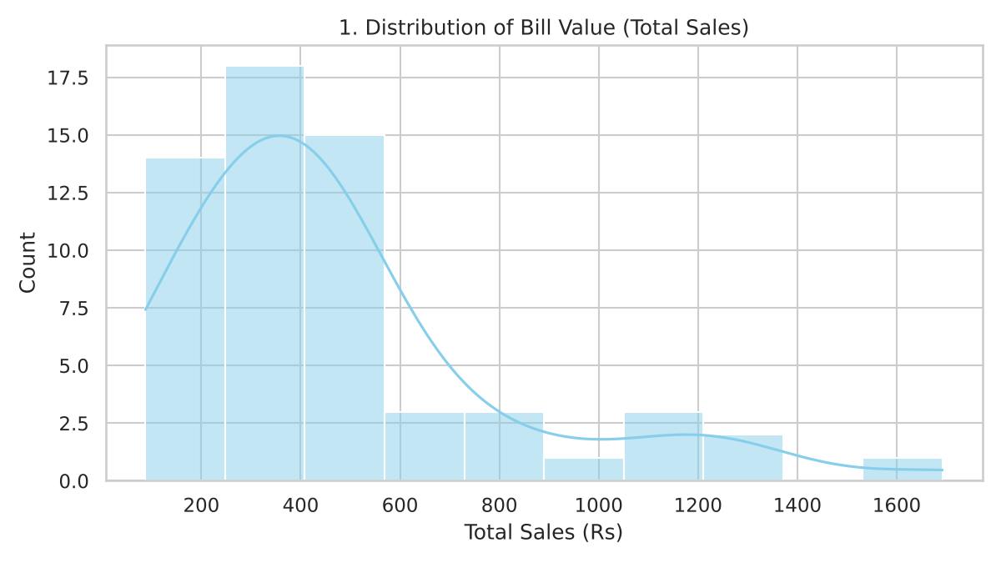
Figure 5.2: Average Unit Price and Total Sales by Category
The grouped bars compare average unit price and average total sales across the six categories.
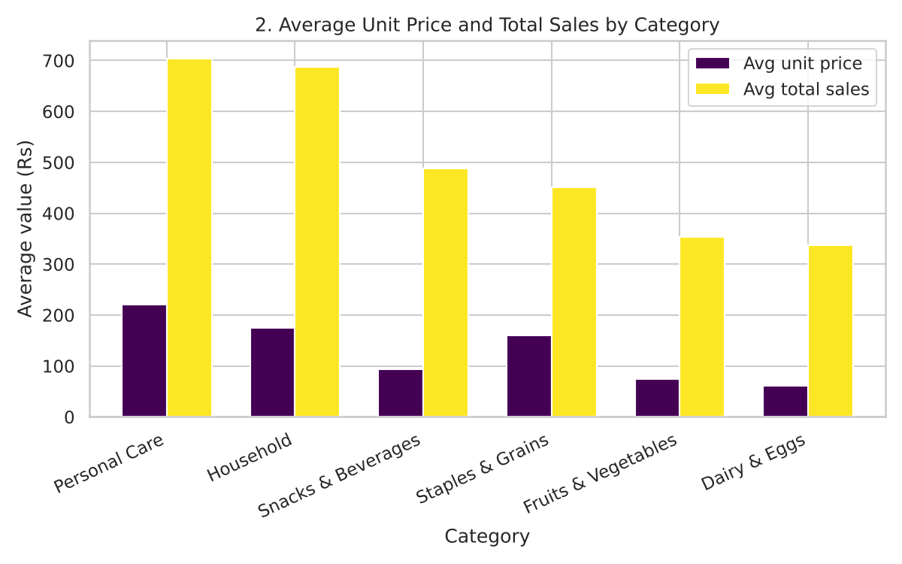
Figure 5.3: Unit Price vs Total Sales
The scatter plot separates bills by customer type and gender for visual comparison.
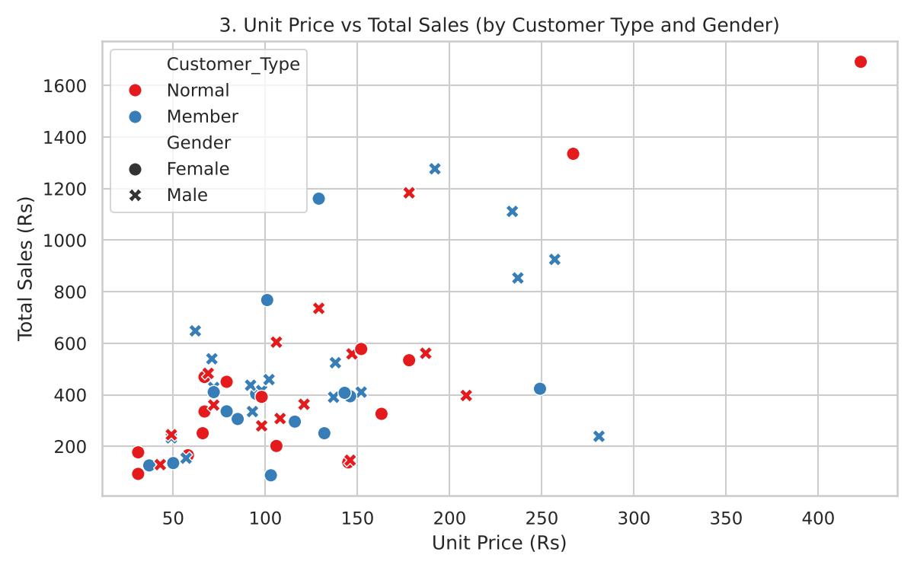
Figure 5.4: Category Sales Count by Payment Mode
The count chart compares the number of bills in each category for the three payment modes.
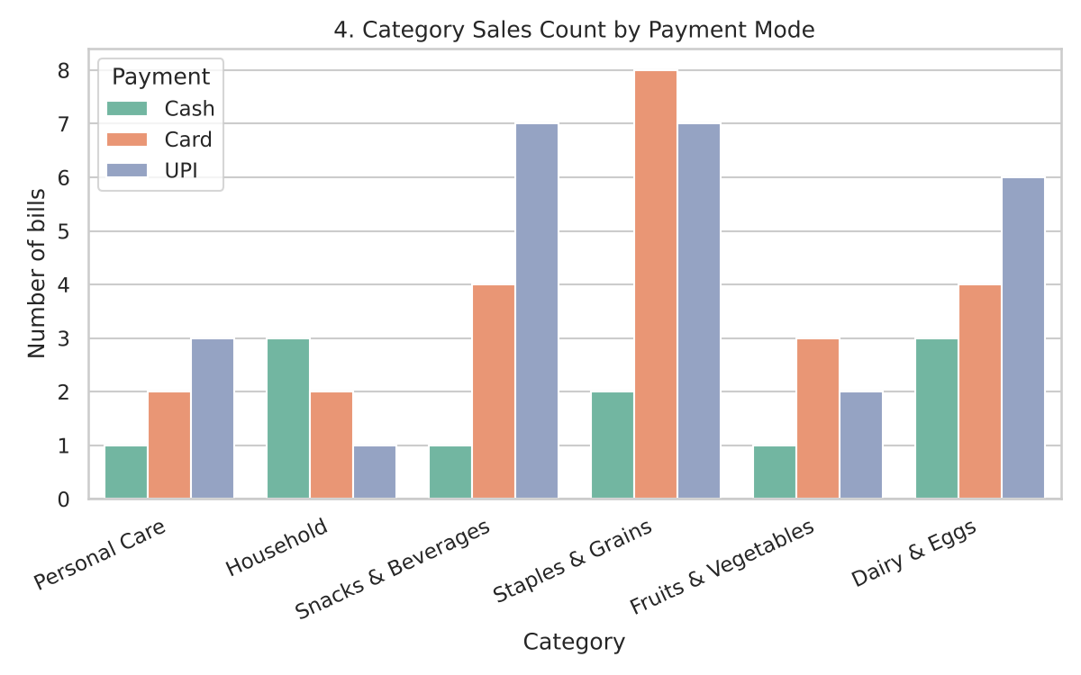

CHAPTER 6: RESULTS AND INTERPRETATION

6.1 Category Performance
Category | Bills | Avg unit price | Avg bill | Total sales
Personal Care | 6 | Rs 220.17 | Rs 703.94 | Rs 4,223.65
Household | 6 | Rs 174.33 | Rs 686.89 | Rs 4,121.35
Snacks & Beverages | 12 | Rs 93.83 | Rs 487.63 | Rs 5,851.60
Staples & Grains | 17 | Rs 159.59 | Rs 450.97 | Rs 7,666.45
Fruits & Vegetables | 6 | Rs 74.67 | Rs 354.12 | Rs 2,124.70
Dairy & Eggs | 13 | Rs 61.54 | Rs 337.40 | Rs 4,386.25

- Staples & Grains has the most bills (17) and the highest total sales (Rs 7,666.45), even though its average bill is moderate. High-priced categories such as Personal Care have fewer bills but larger bills. These are sample counts, not evidence about a real store.

6.2 Payment Mode, Customers and Branches
- UPI is the most common payment mode (26 bills), followed by Card (23) and Cash (11). In Staples & Grains, Card has the most bills (8), and Snacks & Beverages has 7 UPI bills.
- Member customers (31 bills) have an average bill of Rs 480.17, compared with Rs 465.13 for normal customers (29 bills). Average ratings are almost the same (7.63 and 7.64).
- Total sales by branch are Rs 10,091 for Chennai, Rs 9,794 for Trichy and Rs 8,490 for Coimbatore.

6.3 Correlation Heatmap
- The correlation heatmap displays pairwise correlation coefficients among the numeric columns. The largest positive relationships are Unit Price with Total Sales (0.67) and Quantity with Total Sales (0.47). Unit Price and Quantity show a mild negative coefficient of -0.24, which means costly items are usually bought in smaller quantities.
- Discount has a small negative coefficient with Total Sales (-0.15), and Rating has weak coefficients with the other columns (up to 0.25). Because Total_Sales is calculated from price, quantity and discount, its high correlations are partly by construction.

6.4 Interpretation
The visualizations make it easier to compare distributions and relationships in the sample records. Correlation measures linear association, not causation. Because the dataset is small and simulated, the results should be treated as exploratory observations only.
Figure 6.1: Correlation Heatmap
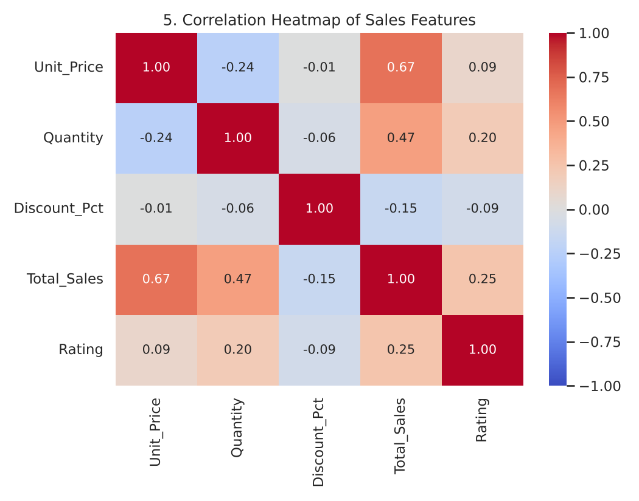

6.5 Project Output
The project output consists of the raw and cleaned sales workbooks, the Python analysis script and five charts. These outputs demonstrate an end-to-end introductory workflow for retail data inspection, preprocessing and visualization.

CHAPTER 7: KEY FINDINGS AND RECOMMENDATIONS

7.1 Key Findings
- The sample dataset contains 60 bills and 11 variables, with a total sales value of Rs 28,374.
- The raw workbook has missing values; the cleaned workbook has no missing values in any column.
- The largest group of bills (18 of 60) falls between about Rs 248 and Rs 408, while a few large bills (up to Rs 1,692) raise the average.
- Personal Care has the highest average bill, while Staples & Grains has the highest total sales and the most bills.
- UPI is the most used payment mode (26 of 60 bills).
- Unit price and quantity show positive correlations with total sales (0.67 and 0.47).

7.2 Recommendations
- Collect a larger, real sales dataset with clearly defined columns, units and date information.
- Keep a data dictionary for every column, including how Total_Sales and discounts are calculated.
- Validate missing-value handling, duplicate bills and plausible price and quantity ranges.
- Use category and payment-mode insights to plan stock, promotions and checkout counters.
- If forecasting is developed later, define the target variable and the train/test split before modeling.
- Evaluate any future model using suitable metrics such as MAE, RMSE or R-squared before business use.

CHAPTER 8: LIMITATIONS AND FUTURE ENHANCEMENTS

8.1 Limitations
- The dataset is simulated and contains only 60 records, so the results cannot be generalized to real stores or customers.
- The dataset has no date or product-level fields, so trends over time and individual product sales cannot be studied.
- Correlation values can be unstable in a small sample and are partly by construction because Total_Sales is calculated from other columns.
- The project does not demonstrate a trained or evaluated machine-learning model.

8.2 Future Enhancements
- Use a larger, real supermarket dataset with dates, product names, stock and store location details.
- Add time-based analysis such as daily, weekly and festival-season sales trends.
- Add market basket analysis to find products that are often bought together.
- Train and compare forecasting models only after defining the prediction target and having adequate data, using cross-validation and suitable metrics.
- Build an interactive sales dashboard for store managers.

CHAPTER 9: CONCLUSION
This mini project demonstrates a basic supermarket and grocery sales analysis workflow using Python, Pandas, Matplotlib and Seaborn. A simulated sample was prepared as raw and cleaned workbooks, and five visualizations were used to explore bill value, product categories, unit price, customer type, payment mode and quantity. The correlation matrix shows positive associations of unit price (0.67) and quantity (0.47) with total sales in this small sample. These findings are exploratory only. A dependable sales analysis or forecasting system would require real, larger and well-documented store data, a properly trained and evaluated model, and review by retail domain experts.

REFERENCES
- Simulated supermarket sales spreadsheets: messy_supermarket_sales.xlsx and cleaned_supermarket_sales.xlsx (generated by eda_supermarket_sales.py).
- Pandas documentation: https://pandas.pydata.org/docs/
- Matplotlib documentation: https://matplotlib.org/stable/
- Seaborn documentation: https://seaborn.pydata.org/
- RedSeer Strategy Consultants, report on India's grocery market and kirana share (January 2026).
- Ken Research, India Supermarket Retail Market Size, Share and Forecast 2025-2032 (August 2026).

APPENDIX: PROJECT FILES AND VISUALIZATIONS
The project materials used for this report include the Python analysis script, raw and cleaned sales spreadsheets, and the visualization outputs.
- eda_supermarket_sales.py
- messy_supermarket_sales.xlsx
- cleaned_supermarket_sales.xlsx
- Supermarket_Grocery_Sales_EDA_Report.docx
- fig1_total_sales_distribution.png — Distribution of bill value
- fig2_avg_price_sales_by_category.png — Average unit price and total sales by category
- fig3_price_vs_sales_scatter.png — Unit price vs total sales
- fig4_category_by_payment.png — Category sales count by payment mode
- fig5_correlation_heatmap.png — Correlation matrix
GITHUB LINK:
[ https://github.com/814725243138-commits/super-market-and-grocery-sales/upload ]

